**Karan Arora**  **R.L. Institute M: 9416974837**

**Max Time : 1 hr** **Class = 12th Chemistry Test**  **Max Marks : 30**

**CHEMICAL KINETICS**

1. A first order reaction has a specific reaction rate of 10 – 2 s – 1 . How much time will it take for 20 g of the reactant to reduce to 5 g?

|  |  |  |  |
| --- | --- | --- | --- |
| a) 238.6 s | b) 138.6 s | c) 346.5 s | d) 693.0 s |

1. Mechanism of a hypothetical reaction X2 + Y2 2XY is given below.

(i) X2 X + X (fast) (ii) X + Y2 XY + Y (slow) (iii) X + Y XY (fast)

The overall order of reaction will be :

|  |  |  |  |
| --- | --- | --- | --- |
| a) 1 | b) 2 | c) 0 | d) 1.5 |

1. When initial concentration of a reactant is doubled in a reaction, its half-life period is not affected. The order of the reaction is

|  |  |
| --- | --- |
| a) zero | b) first |
| c) second | d) more than zero but less than first |

1. The rate constant of the reaction A B is 0.6 x 10 – 3 mole per second. If the concentration of A is 5 M then concentration of B after 20 minutes is :

|  |  |  |  |
| --- | --- | --- | --- |
| a) 1.08 M | b) 3.60 M | c) 0.36 M | d) 0.72 M |

1. Which one of the following statements for the order of a reaction is incorrect?

a) Order is not influenced by stoichiometric coefficient of the reactants

b) Order of reaction is sum of power to the concentration terms of reactants to express the rate of reaction

c) Order of reaction is always whole number

d) Order can be determined only experimentally

1. During the kinetic study of the reaction 2 A + B C + D, following results were obtained

|  |  |  |  |
| --- | --- | --- | --- |
| Run | A/mol L – 1 | B/mol L – 1 | Initial rate of formation of D/mol L – 1 min – 1 |
| I | 0.1 | 0.1 | 6.0 X 10 – 3 |
| II | 0.3 | 0.2 | 7.2 X 10 – 2 |
| III | 0.3 | 0.4 | 2.88 X 10 – 1 |
| IV | 0.4 | 0.1 | 2.40 X 10 – 2 |

Based on the above data which one of the following is correct?

|  |  |  |  |
| --- | --- | --- | --- |
| a) Rate = k [A]2 [B] | b) Rate = k [A] [B] | c) Rate = k [A]2 [B]2 | d) Rate = k [A] [B]2 |

1. For the reaction, N2 (g) + 3 H2 (g) 2 NH3 (g), if [NH3]/t = 2 x 10 – 4 mol L – 1 s – 1, what is the value of [H2]/t?

|  |  |  |  |
| --- | --- | --- | --- |
| a) 3 x 10 – 4 mol L – 1 s – 1 | b) 4 x 10 – 4 mol L – 1 s – 1 | c) 6 x 10 – 4 mol L – 1 s – 1 | d) 1 x 10 – 4 mol L – 1 s – 1 |

1. For the reaction, A + B products, it is observed that
2. On doubling the initial concentration of A only, the rate of reaction is also doubled and
3. On doubling the initial concentrations of both A and B, there is a change by a factor of 8 in the rate of the reaction.

The rate of this reaction is, given by

|  |  |  |  |
| --- | --- | --- | --- |
| a) Rate = k [A]2 [B] | b) Rate = k [A] [B]2 | c) Rate = k [A]2 [B]2 | d) Rate = k [A] [B] |

1. Half-life period of a first order reaction is 1386 s. The specific rate constant of the reaction is :

|  |  |  |  |
| --- | --- | --- | --- |
| a) 5.0 x 10 – 3 s – 1 | b) 0.5 x 10 – 2 s – 1 | c) 0.5 x 10 – 3 s – 1 | d) 5.0 x 10 – 3 s – 1 |

1. If 60 % of a first order reaction was completed in 60 min, 50 % of the same reaction would be completed in approx. (log 4 = 0.60 , log 5 = 0.69)

|  |  |  |  |
| --- | --- | --- | --- |
| a) 50 min | b) 45 min | c) 60 min | d) 40 min |

1. If a first order reaction, A B, if K is rate constant and initial concentration of the reactant A is 0.5 M, then the half-life is

|  |  |  |  |
| --- | --- | --- | --- |
| a) $\frac{0.698}{0.5 K}$ | b) $\frac{\log{2}}{K}$ | c) $\frac{\log{2}}{K \sqrt{5}}$ | d) $\frac{\ln{2}}{K}$ |

1. Considered the reaction, N2 (g) + 3 H2 (g) 2 NH3 (g). The equality relationship between $\frac{d[{NH}_{3}]}{dt}$ and $-\frac{d[H_{2}]}{dt}$ is

|  |  |
| --- | --- |
| a) $\frac{d[{NH}_{3}]}{dt}$ = $-\frac{1}{3}\frac{d[H_{2}]}{dt}$ | b) + $\frac{d[{NH}_{3}]}{dt}$ = $-\frac{2}{3}\frac{d[H_{2}]}{dt}$ |
| c) $+ \frac{d[{NH}_{3}]}{dt}$ = $-\frac{3}{2}\frac{d[H_{2}]}{dt}$ | d) $\frac{d[{NH}_{3}]}{dt}$ = $-\frac{d[H_{2}]}{dt}$ |

1. For the reaction, 2 A + B → 3 C + D, which of the following does not express the reaction rate?

|  |  |  |  |
| --- | --- | --- | --- |
| a) $-\frac{d[C]}{3dt}$ | b) $-\frac{d[B]}{dt}$ | c) $\frac{d[D]}{dt}$ | d) $-\frac{d[A]}{2dt}$ |

1. For a first order reaction A B, the reaction rate at reactant concentration of 0.01M is found to be 2 x 10 – 5 mol L – 1 sec – 1. The half-life period of the reaction is :

|  |  |  |  |
| --- | --- | --- | --- |
| a) 220 s | b) 30 s | c) 300 s | d) 347 s |

1. The rate of first order reaction is 1.5 x 10 – 2 mol L – 1 min – 1 at 0.5 M concentration of the reactant. The half-life of the reaction is :

|  |  |  |  |
| --- | --- | --- | --- |
| a) 0.383 min | b) 23.1 min | c) 8.73 min | d) 7.53 min |

1. If the rate of a reaction is equal to the rate constant, the order of the reaction is :

|  |  |  |  |
| --- | --- | --- | --- |
| a) 2 | b) 3 | c) 0 | d) 1 |

1. The reaction, A B follows first order kinetics. The time taken for 0.8 mole of A to produce 0.6 mole of B is 1hr. What is the time taken for the conversion of 0.9 mole of A to 0.675 mole of B?

|  |  |  |  |
| --- | --- | --- | --- |
| a) 0.25 h | b) 2 h | c) 1 h | d) 0.5 h |

1. 3 A B + C It would be a zero order reaction, when

a) The rate of reaction is proportional to square of concentration of A

b) The rate of reaction remain same at any concentration of A

c) The rate remains unchanged at any concentration of B and C

d) The rate of reaction doubles if concentration of B is increased to double

1. 3 A 2 B , rate of reaction $+\frac{d[B]}{dt}$ is equal to

|  |  |  |  |
| --- | --- | --- | --- |
| a) $-\frac{3}{2}\frac{d[A]}{dt}$ | b) $-\frac{2}{3}\frac{d[A]}{dt}$ | c) $-\frac{1}{3}\frac{d[A]}{dt}$ | d) + 2 $\frac{d[A]}{dt}$ |

1. For the reaction, 2 N2O5 → 4 NO2 + O2, rate and rate constant are 1.02 x 10 – 4 and 3.4 x 10 – 5  s – 1 respectively, then concentration of N2O5 at that time will be :

|  |  |  |  |
| --- | --- | --- | --- |
| a) 1.732 | b) 3 | c) 1.02 x 10 – 4 | d) 3.4 x 105 |

1. For a first order reaction, the half-life period is independent of :

|  |  |
| --- | --- |
| a) initial concentration | b) cube root of initial concentration |
| c) first power of final concentration | d) square root of final concentration |

1. The experimental data for the reaction, 2 A + B2 2 AB

|  |  |  |  |
| --- | --- | --- | --- |
| Exp. | [A] | [B] | Rate (M s – 1) |
| I | 0.50 | 0.50 | 1.6 X 10 – 4 |
| II | 0.50 | 1.00 | 3.2 X 10 – 4 |
| III | 1.00 | 1.00 | 3.2 X 10 –4 |

The rate equation for given data is :

|  |  |  |  |
| --- | --- | --- | --- |
| a) Rate = k [B2] | b) Rate = k [B2]2 | c) Rate = k [A]2 [B]2 | d) Rate = k [A]2 [B] |

1. The plot of concentration of the reactant versus time for a reaction is a straight line with a negative slope. This reaction follows:

|  |  |
| --- | --- |
| a) zero order rate equation | b) first order rate equation |
| c) second order rate equation | d) third order rate equation |

1. A substance A decomposes by a first order reaction starting initially with [A] = 2.00 m and after 200 min, [A] becomes 0.15 m. For this reaction t1/2 is :

|  |  |  |  |
| --- | --- | --- | --- |
| a) 53.49 min | b) 50.49 min | c) 48.45 min | d) 46.45 min |

1. For exothermic reaction, the energy of activation of the reactants is

a) Equal to the energy of activation of products

b) Less than the energy of activation of products

c) Greater than the energy of activation of products

d) Sometimes greater and sometimes less than that of the products.

1. A + B product, dx/dt = k [A]a [B]b. If dx/dt = k, then order is :

|  |  |  |  |
| --- | --- | --- | --- |
| a) 4 | b) 2 | c) 1 | d) 0 |

1. For the reaction, 2 A + 3 B product, A is in excess and on changing the concentration of B from 0.1 M to 0.4 M, the rate becomes doubled. Thus, rate law

|  |  |  |  |
| --- | --- | --- | --- |
| a) dx/dt = k [A]2 [B]3 | b) dx/dt = k [A] [B] | c) dx/dt = k [A]0 [B]2 | d) dx/dt = k [B]1/2 |

1. A reaction of first order completed 90 % in 90 minutes hence, it is completed 50 % in approx..

|  |  |  |  |
| --- | --- | --- | --- |
| a) 50 min | b) 54 min | c) 27 min | d) 62 min |

1. For the zeroth order reaction, sets I and II are given, hence, x is

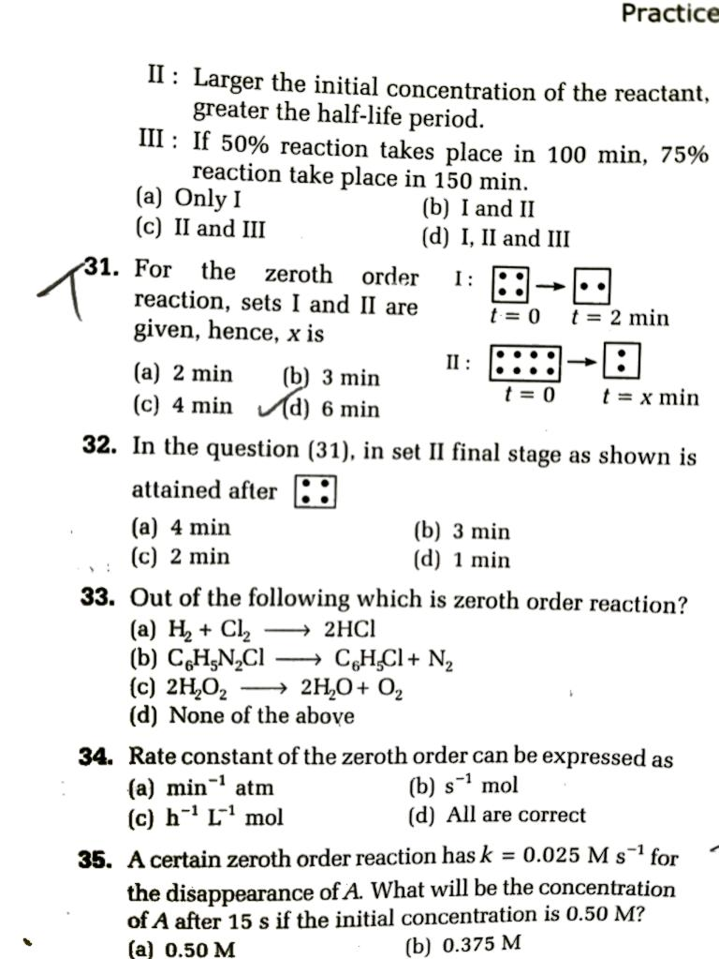 

|  |  |  |  |
| --- | --- | --- | --- |
| a) 2 min | b) 3 min | c) 4 min | d) 6 min |

1. Half-life of first order and zeroth order reactions are same. ratio of rates at the start of reaction is :

|  |  |  |  |
| --- | --- | --- | --- |
| a) 0.693 | b) $\frac{1}{0.693}$ | c) 2 x 0.693 | d) $\frac{2}{0.693}$ |

**[Class =12th]**

**Answers**

**Topic: Chemical Kinetics**

|  |
| --- |
| 1. b |
| 1. d |
| 1. b |
| 1. d |
| 1. c |
| 1. d |
| 1. a |
| 1. b |
| 1. c |
| 1. b |
| 1. d |
| 1. b |
| 1. a |
| 1. d |
| 1. b |
| 1. c |
| 1. c |
| 1. b |
| 1. b |
| 1. b |
| 1. a |
| 1. a |
| 1. b |
| 1. a |
| 1. b |
| 1. d |
| 1. d |
| 1. c |
| 1. d |
| 1. c |